Grazitti Corporation- Test Plan
Test plan for Grazitti Corporation – UI Testing in Banking Application.

22/07/2021
Rahul Mandal

Sample Test Plan
–

OrangeHRM Live Project Training

©
www.SoftwareTestingHelp.com

Version: 1.0
Created: 20/07/2021
Last Updated: 22/07/2021
Status: DRAFT
Revision and Signoff Sheet
Document History -
Version | Date | Author | Description of Change
1 | 20/07/2021 | Rahul Mandal | Draft
2 | 20/07/2021 | Rahul Mandal | Draft - Reviewed

Approvers List -
Name | Role | Approver / Reviewer | Approval / Review Date

Reference Documents -
Version | Date | Document Name

Table of Contents

- INTRODUCTION 5
  - Purpose 5
  - Project Overview 5
  - Audience 5
- TEST STRATEGY 5
  - Test Objectives 5
  - Test Assumptions 6
  - Test Principles 7
  - Data Approach 7
  - Scope and Levels of Testing 7
    - Exploratory 7
    - Functional Test 8
TEST ACCEPTANCE CRITERIA 8 TEST DELIVERABLES 8 MILESTONE LIST 9
    - User Acceptance Test (UAT) 9

TEST DELIVERABLES 9
2.6. Test Effort Estimate 10
- EXECUTION STRATEGY 10
  - Entry and Exit Criteria 10
  - Test Cycles 11
  - Validation and Defect Management 11
  - Test Metrics 12
  - Defect tracking & Reporting 13
- TEST MANAGEMENT PROCESS 13
  - Test Management Tool 13
  - Test Design Process 14
  - Test Execution Process 15
  - Test Risks and Mitigation Factors 16
4.1. Communications Plan and Team Roster 17

4.2. Role Expectations 17
4.2.1. Project Management 18
4.2.2. Test Planning (Test Lead) 18
4.2.3. Test Team 18
4.2.4. Test Lead 18
4.2.5. Development Team 18
5. TEST ENVIRONMENT 19

1. INTRODUCTION

1.1. Purpose
This test plan describes the testing approach and overall framework that will drive the testing of the End to End Functional Test Case on Gmail Application. The document introduces:
- Test Strategy: rules the test will be based on, including the givens of the project (e.g.: start / end dates, objectives, assumptions); description of the process to set up a valid test (e.g.: entry / exit criteria, creation of test cases, specific tasks to perform, scheduling, data strategy).
- Execution Strategy: describes how the test will be performed and process to identify and report defects, and to fix and implement fixes.
- Test Management: process to handle the logistics of the test and all the events that come up during execution (e.g.: communications, escalation procedures, risk and mitigation, team roster)

1.2. Project Overview
[Insert Project Summary here]
The functionality of this module spans through both systems, making information syncing simple. All information is subject to company’s defined security policy, where user can only view the information user is authorized to.

1.3. Audience
- QA Team members – Perform tasks specified in this document, and provide input and recommendations on this document.
- QA Manager – Plans for the testing activities in the overall project schedule, reviews the document, tracks the performance of the test according to the task herein specified, approves the document and is accountable for the results.
- Technical Team – Ensures that the test plan and deliverables are in line with the design, provides the environment for testing and follows the procedures related to the fixes of defects.
- Business analysts will provide their inputs on functional changes.

2. TEST STRATEGY

2.1. Test Objectives
The objective of the test is to verify that the functionality of [Project name] works according to the specifications.
[Insert Requirement Overview/Document here]
The test will execute and verify the test scripts, identify, fix and retest all high and medium severity defects per the entrance criteria, prioritize lower severity defects for future fixing via Conditional Release.
The final product of the test is twofold:
- A production-ready software;
- A set of stable test scripts that can be reused for Functional and UAT test execution.

2.2. Test Assumptions
Key Assumptions
- Production like data required and be available in the system prior to start of Functional Testing
- In each testing phase, consecutive testing cycles will be initiated based on System health in previous cycle. For e.g. Cycle 2 will be initiated if the defect rate is high in Cycle 1.
General
- Exploratory Testing would be carried out once the build is ready for testing ● Performance testing is not considered for this estimation.
- All the defects would come along with a snapshot JPEG format
- The Test Team assumes all necessary inputs required during Test design and execution will be supported by Development/Management appropriately.
- Test case design activities will be performed by QA Group.
- Test environment and preparation activities will be owned by Dev Team/QA Team.
- Dev team will provide Defect fix plans based on the Defect meetings during each cycle to plan. The same will be informed to Test team prior to start of Defect fix cycles
- The defects will be tracked through JIRA only. Any defect fixes planned will be shared with Test Team prior to applying the fixes on the Test environment ● QA Manager will review and sign-off all test deliverables.
- QA team has the knowledge and experience necessary, or has received adequate training in the system, the project and the testing processes.
- There is no environment downtime during test due to outages or defect fixes.
- The system will be treated as a black box; if the information shows correctly online and in the reports, it will be assumed that the database is working properly.

Functional Testing
- During Functional testing, testing team will either use preloaded data created by Dev team or will create test scenario specific data at the time of execution.
- The Test Team will be perform Functional testing only on [Project Name].

2.3. Test Principles
- Testing will be focused on meeting the business objectives, cost efficiency, and quality.
- There will be common, consistent procedures for all teams supporting testing activities.
- Testing processes will be well defined, yet flexible, with the ability to change as needed.
- Testing activities will build upon previous stages to avoid redundancy or duplication of effort.
- Testing environment and data will emulate a production environment as much as possible.
- Testing will be a repeatable, quantifiable, and measurable activity.
- Testing will be divided into distinct phases, each with clearly defined objectives and goals.
- There will be entrance and exit criteria.

2.4. Data Approach
● In functional testing, [Project Name] will either utilize preloaded data or new test data will be created based on test scenario.

2.5. Scope and Levels of Testing

2.5.1. Exploratory
PURPOSE: the purpose of this test is to make sure critical defects are removed before the next levels of testing can start.
SCOPE: First level navigation, user and admin modules
TESTERS: Testing team.
METHOD: this exploratory testing is carried out in the application without any test scripts and documentation
TIMING: at the beginning of each cycle.

2.5.2. Functional Test
PURPOSE: Functional testing will be performed to check the functions of application. The functional testing is carried out by feeding the input and validates the output from the application.
Scope: The below excel sheet details about the scope of Functional test. Note: The scope is high level due to changes in the requirement.
[Sinergify _ Test cases (1).xlsx]
TESTERS: Testing Team.
METHOD: The test will be performed according to Functional scripts, which are stored in Test Maintenance system.
TIMING: after Exploratory test is completed.

TEST ACCEPTANCE CRITERIA
- Approved Functional Specification document, Use case documents must be available prior to start of Test design phase.
- Test cases approved and signed-off prior to start of Test execution
- Development completed, unit tested with pass status and results shared to Testing team to avoid duplicate defects.
- Test environment with application installed, configured and ready to use state
Readiness

Development completed & unit tested Application deployed and system ready for
testing on Test environment
Production like data is available to test all functionalities.


Defect fixes planned based on Defect triage (Unit Testing) and evaluation criteria
Sign-off


Approved Functional Specification Document
Approved Use cases
Approved Test cases

TEST DELIVERABLES

S.No. | Deliverable Name | Author | Reviewer
1. | Test Plan | QA Manager | Test Team/ Dev Team/ Project Manager.
2. | Functional Test Cases | Test Team | Dev Team.
3. | Logging Defects | Test Team | Test Lead/ Programming Lead(Sandeep)
4. | Daily/weekly status report | Test Team/ Test Lead | Test Lead/ QA Manager/ Dev Team/  Dev Manager
5. | Test Closure report | Test Lead | QA Manager

Sign-off Readiness



Approved Regression Test scenarios. Development completed and latest Suites
created as per requirement Build available and installed.
All automated cases are checked in
Jenkins server is up and running.

2.6. Test Work Plan

Work plan
timeline.xlsx

3. EXECUTION STRATEGY

3.1. Entry and Exit Criteria
- The entry criteria refer to the desirable conditions in order to start test execution; only the migration of the code and fixes need to be assessed at the end of each cycle.
- The exit criteria are the desirable conditions that need to be met in order proceed with the implementation.
- Entry and exit criteria are flexible benchmarks. If they are not met, the test team will assess the risk, identify mitigation actions and provide a recommendation. All this is input to the Project Management for a final “go-no go” decision.
- Entry criteria to start the execution phase of the test: the activities listed in the Test Planning section of the schedule are 100% completed.
- Entry criteria to start each cycle: the activities listed in the Test Execution section of the schedule are 100% completed at each cycle.

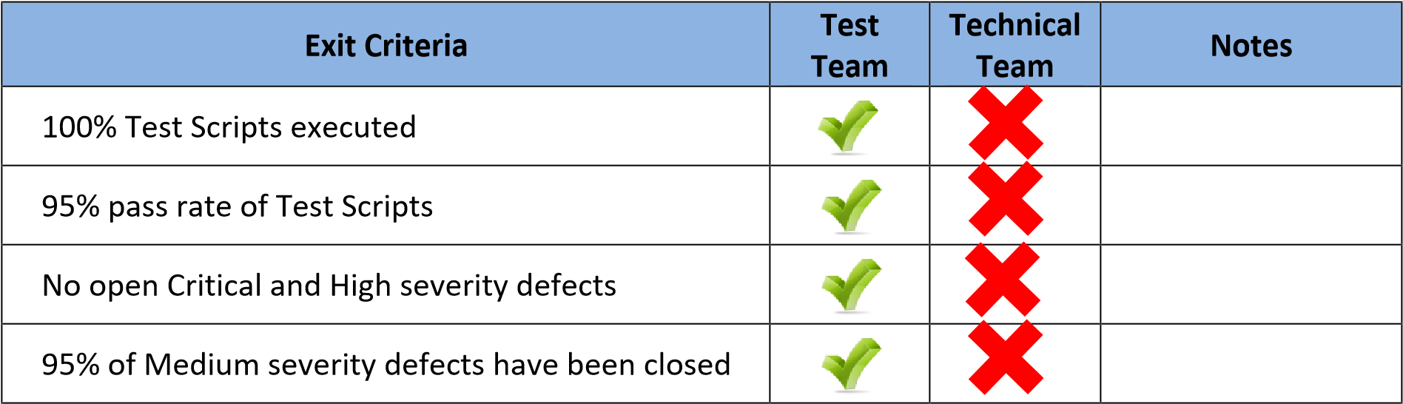

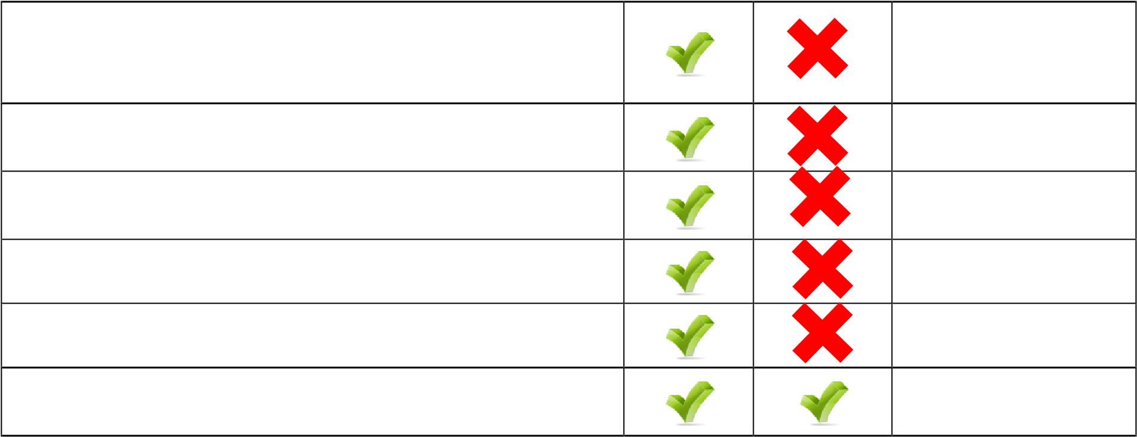
All remaining defects are either cancelled or
documented as Change Requests for a future
release
All expected and actual results are captured and
documented with the test script
All test metrics collected based on reports from
Test Management system
All defects logged in Jira.

Test Closure Report completed and signed off

Test environment cleanup completed and a new
back up of the environment

3.2. Test Cycles
- There will be two cycles for functional testing. Each cycle will execute all the scripts.
- The objective of the first cycle is to identify any blocking, critical defects, and most of the high defects. It is expected to use some work-around in order to get to all the scripts.
- The objective of the second cycle is to identify remaining high and medium defects, remove the work-around from the first cycle, correct gaps in the scripts and obtain performance results.

3.3. Validation and Defect Management
- It is expected that the testers execute all the scripts in each of the cycles described above. However it is recognized that the testers could also do additional testing if they identify a possible gap in the scripts.
- If a gap is identified in test scenarios, the scripts and traceability matrix will be updated and then a defect logged against the scripts.
- The defects will be tracked through JIRA only. The test team will share complete test report on a daily basis. The technical team can gather additional details from the Defect Coordinator. The technical team will work on fixes.
- Any Blocker and Critical issues have to be reported right away.
- It is the responsibility of the tester to open the defects, link them to the corresponding script, assign an initial severity and status, retest and close the defect.
Defects found during the Testing will be categorized as follows:
Severity |  | Impact
1 (Critical) | ▪ | This bug is critical enough to crash the system, cause file corruption, or cause potential data loss
 | ▪ | It causes an abnormal return to the operating system (crash or a system failure message appears).
 | ▪ | It causes the application to hang and requires re-booting the system.
2 (High) | ▪ | It causes a lack of vital program functionality with workaround.
3 (Medium) | ▪ | This Bug will degrade the quality of the System. However there is an intelligent workaround for achieving the desired functionality - for example through another screen.
 | ▪ | This bug prevents other areas of the product from being tested. However other areas can be independently tested.
4 (Low) | ▪ | There is an insufficient or unclear error message, which has minimum impact on product use.
5(Cosmetic) | ▪ | There is an insufficient or unclear error message that has no impact on product use.

3.4. Test Metrics
Test metrics to measure the progress and level of success of the test will be developed and shared with the QA Manager. The below are some of the metrics
Report | Description | Frequency
Test  preparation &  Execution  Status | To report on % complete, % Pass, % Fail  Defects severity wise Status – Open, closed, any other Status | Weekly / Daily (optional)
Daily execution status | To report on Pass, Fail, Total defects, highlight Showstopper/ Critical defects | Daily
Project  Weekly Status report | Project driven reporting (As requested by PM) | Weekly – If project team needs weekly update apart from daily and there is
 |  | template available with project team to use.

3.5. Defect tracking & Reporting
Following flowchart depicts Defect Tracking Process:
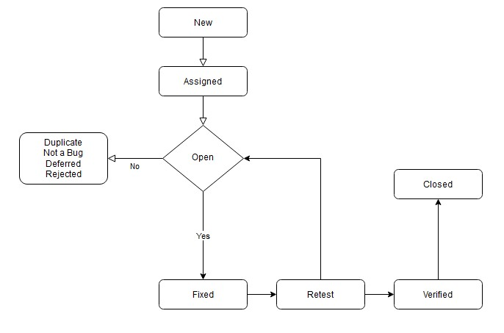

4. TEST MANAGEMENT PROCESS

4.1. Test Management Tool
TestLink is the tool used for Test Management. All testing artifacts such as Test cases, test results are updated in testlink.
- Each resource in the Testing team will be provided with Read/Write access to add/modify Test cases in TestLink.
- During the Test Design phase, all test cases are written and updated in the TestLink. Any change to the test case will be directly updated.
- Each Tester will directly access their respective assigned test cases and update the status of each executed step.
- Any defect encountered will be raised in Mantis linking to the particular Test case/test step in testlink.
- During Defect fix testing, defects are re-assigned back to the tester to verify the defect fix. The tester verifies the defect fix and updates the status in Mantis.

4.2. Test Design Process


Understanding
Requirements

Establishing
Traceability
Matrix

Preparation of
Test cases

SME /Peer
Review of Test
cases

Incorporating
Review
comments in
test cases

Automation of
Test cases

- The tester will understand each requirement and prepare corresponding test cases to ensure all requirements are covered.
- Each Test case will be mapped to Use cases to Requirements as part of Traceability matrix.
- During the preparation phase, tester will use the prototype, use case and functional specification to write step by step test cases.
- Testers will maintain a clarification Tracker sheet and same will be shared periodically with the Dev team and accordingly the test case will be updated. The clarifications may sometimes lead to Change Requests or not in scope or detailing implicit requirements.
- Any subsequent changes to the test case if any will be directly updated.

4.3. Test Execution Process


Execute each
of the test
step in test
case

Mark Status
as Pass/Fail

Raise defects
for the failed
test cases

Send the daily
status report

Participate in
Defect Triage
cycle and
explain the
defects

Complete the
test execution
of all the test
cases

Automation
Suite will run
periodically to
maintain build
stability.

- Once all Test cases are approved and the test environment is ready for testing, tester will start exploratory test of the application to ensure the application is stable for testing.
- Each Tester is assigned Test cases.
- Testers to ensure necessary access to the testing environment. If any issues, will be escalated to the Test Lead and in turn to the QA Manager as escalation.
- If any showstopper during exploratory testing will be escalated to the respective development SPOCs for fixes.
- Each tester performs step by step execution and updates the executions status. The tester enters Pass or Fail Status for each of the step.
- Tester will prepare a Run chart with day-wise execution details
- If any failures, defect will be raised as per severity guidelines detailing steps to simulate along with screenshots if appropriate.
- Daily Test execution status as well as Defect status will be reported to all stakeholders.
- Testing team will participate in defect triage meetings in order to ensure all test cases are executed with either pass/fail category.
- If there are any defects that are not part of steps but could be outside the test steps, such defects need to be captured in JIRA and map it against the test case level or at the specific step that issue was encountered.
- This process is repeated until all test cases are executed fully with Pass/Fail status.
- During the subsequent cycle, any defects fixed applied will be tested and results will be updated.
- Automation suite will execute with each new build to ensure build stability.
- Test team to validate and report Automation failures upon proper investigation. If an gaps are found in test, the automation scripts need to be updated accordingly.
As per Process, final sign-off or project completion process will be followed.

4.4. Test Risks and Mitigation Factors
Risk | Prob. | Impact | Mitigation Plan
SCHEDULE  Testing schedule is tight. If the start of the testing is delayed due to design tasks, the test would be extended based on Stakeholders decision. | High | High | - The testing team can control the preparation tasks (in advance) and the early communication with involved parties.  - Some buffer has been added to the schedule for contingencies, although not as much as best practices advise.
RESOURCES  Team needs to ready and on boarded in time. | Medium | High | Deviations from the estimation could derive in delays in the testing.
DEFECTS  Defects found at a late stage of the cycle or at a late cycle need to | Medium | High | Defect management plan is in place to ensure prompt communication and fixing of issues.
either converted to CRs or deferred based on Severity.

SCOPE  Scope completely defined | Medium | Medium | Scope is well defined but the changes are in the functionality keep on changing.
Non-availability of Test environment and accessibility | Medium | High | Due to non availability of the environment, the schedule gets impacted and will lead to delayed start of Test execution.
Delayed Testing Due To new Issues | Medium | High | During testing, there is a good chance that some “new” defects may be identified and may become an issue that will take time to resolve.
1.1. Communications Plan and Team Roster

1.2. Role Expectations
The following list defines in general terms the expectations related to the roles directly involved in the management, planning or execution of the test for the project.
 | Roles | Name | Contact Info
1. | QA Manager
2. | Test Lead
3. | Project Manager
4. | Development Lead
5. | Testing Team
6. | Development Team

1.2.1. QA Management
- Project Manager: reviews the content of the Test Plan, Test Strategy and Test Estimates signs off on it.
- Prepares and shared Test Status reports.
- Provide guidelines on how to manage defects.
- Assist in the validation of results (if requested).

1.2.2. Test Planning (Test Lead)
- Ensure entrance criteria are used as input before start the execution.
- Develop test plan and the guidelines to create test conditions, test cases, expected results and execution scripts.
- Communicate to the test team any changes that need to be made to the test deliverables or application and when they will be completed.
- Connect functional and technical team to test team personnel (if needed).

1.2.3. Test Team
- Develop test conditions, test cases, expected results, and execution scripts.
- Perform execution and validation.
- Identify, document and prioritize defects according to the guidance provided by the Test lead.
- Re-test after software modifications have been made according to the schedule.
- Prepare testing metrics and provide regular status.

1.2.4. Test Lead
- Acknowledge the completion of a section within a cycle.
- Give the OK to start next level of testing.
- Facilitate defect communications between testing team and technical / development team.

1.2.5. Development Team
- Review testing deliverables (test plan, cases, scripts, expected results, etc.) and provide timely feedback.
- Assist in the validation of results (if requested).
- Support the development and testing processes being used to support the project.
- Certify correct components have been delivered to the test environment at the points specified in the testing schedule.
- Keep project team and leadership informed of potential software delivery date slips based on the current schedule.
- Conduct first line investigation (Unit Tests) into execution discrepancies and assist test executors in creation of accurate defects.
- Implement fixes to defects according to schedule.

2. TEST ENVIRONMENT
Following systems should be setup for QA environment:-
- Salesforce
- Mantis
- TestLink
- ZOHO
- Any other system dependencies
a. [Note the dependencies for future release]

3. APPROVALS

The Names and Titles of all persons who must approve this plan.
Signature: | Rahul
Name: | Rahul Mandal
Role: | Software Tester
Date: | 22/07/2021

